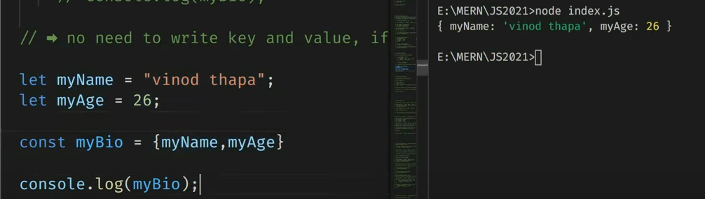For in -> returns index

For of -> returns elements

Foreach -> break and continue not acceptable, it returns undefined because it edits original array

Searching and filter in an array:

Indexof()

How to sort and and compare an array

Array CRUD

Create: **push()**

Push method returns new length of an array.

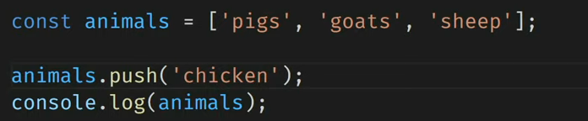

**Unshift():** adds one or more elements to the beginning of an array and returns new length of an array.

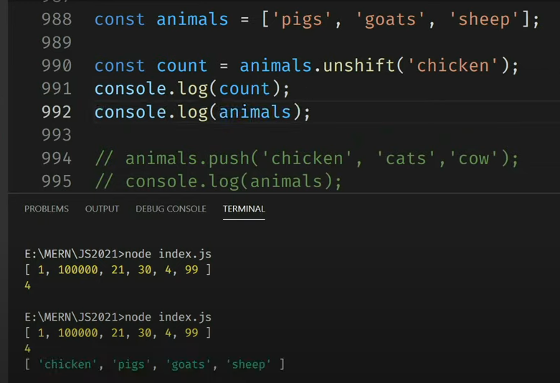

**Pop**(): removes the last element and returns that element. It changes the length of an array.

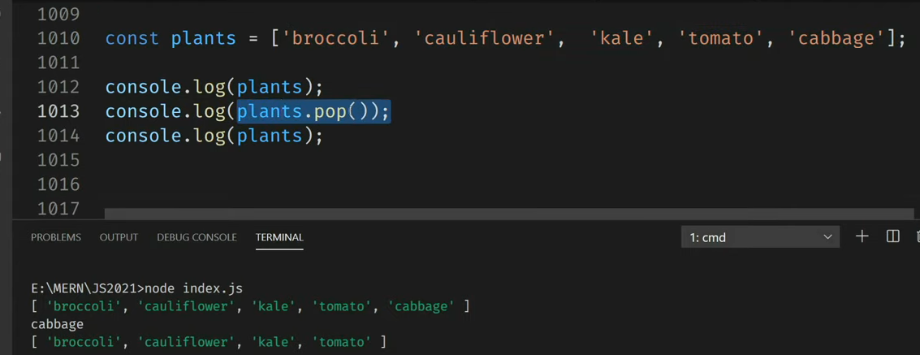

**Shift**():

It removes the first element and returns that removed element.

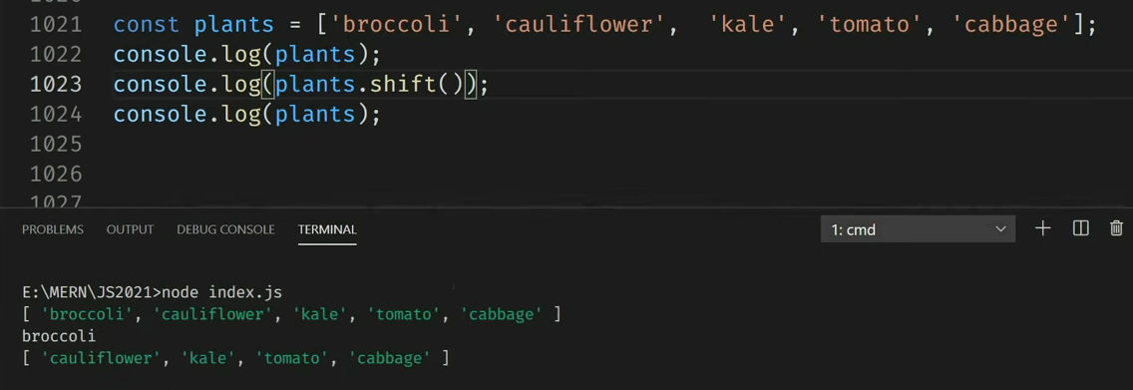

**Splice Method**: it is used for deleting. It returns deleted element.

Add dec at the end of the array

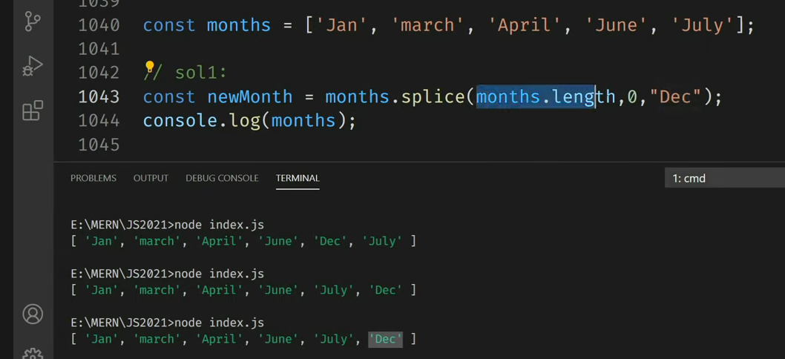

Update:

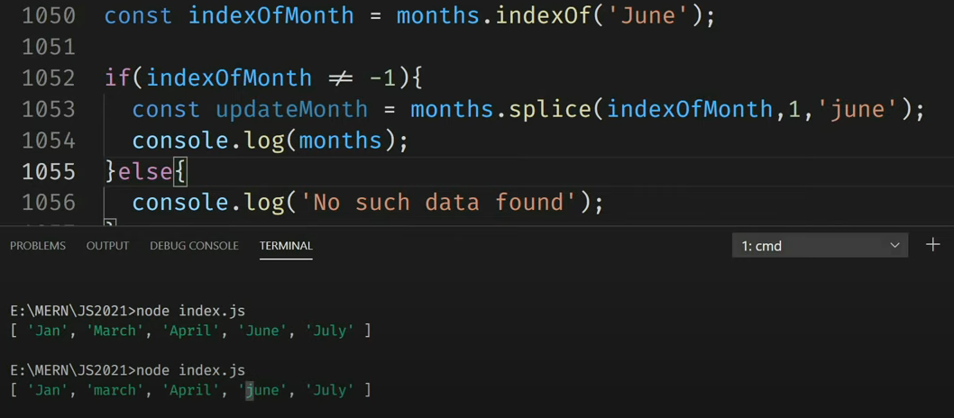

Delete

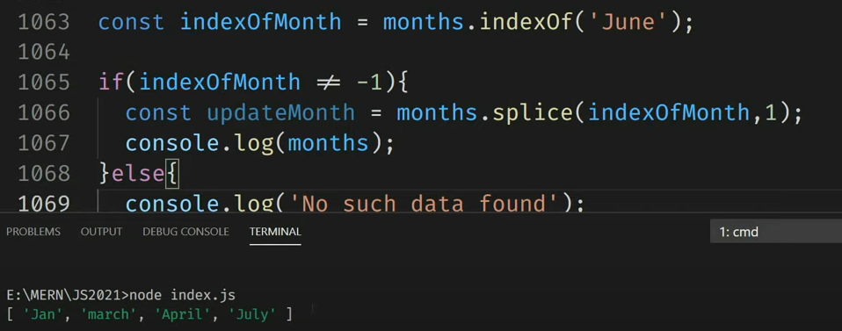

Delete using infinity:

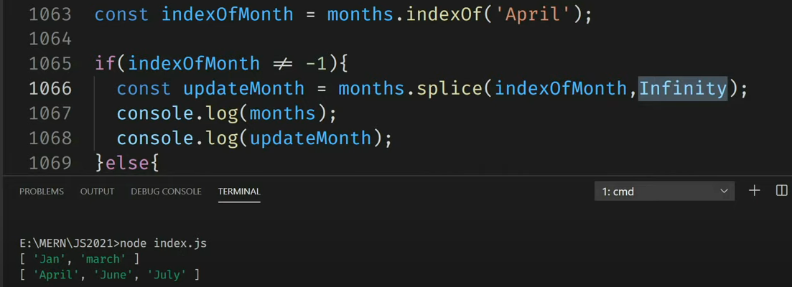

**Map Method**: It returns a new array containing the results of calling a function on every element in this array. It returns the new array without mutating the original array.

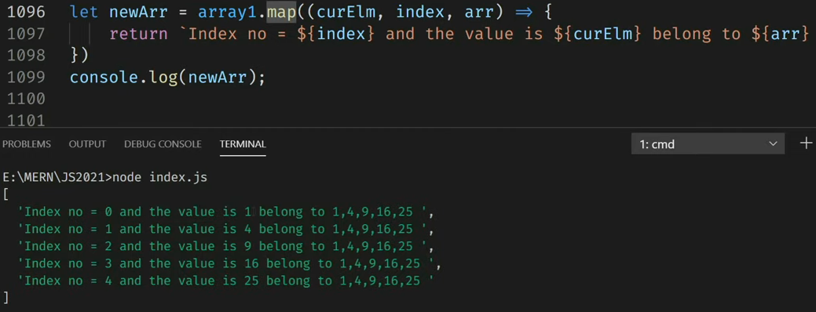

**Filter method**:

**Reduce method**: it flattens an array which means it converts the 3d or 2d array into a single dimension array. It takes four arguments: accumulator, current value, current index, source array. Don’t use reduce method to flatten an array.

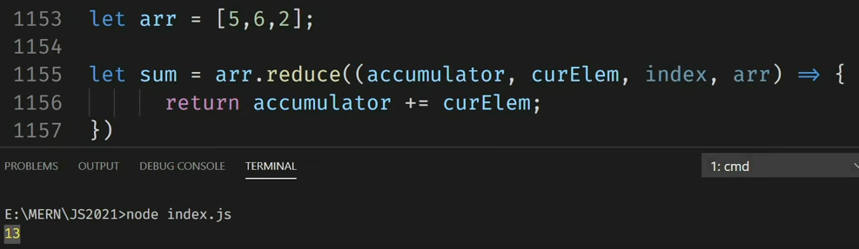

**Strings**:

String() constructor gives result in array.

Escape characters: \\ “” ‘’

”we are so called \“Vikings\” from the north.”

**indexOf():** returns -1 is there are no any searched data

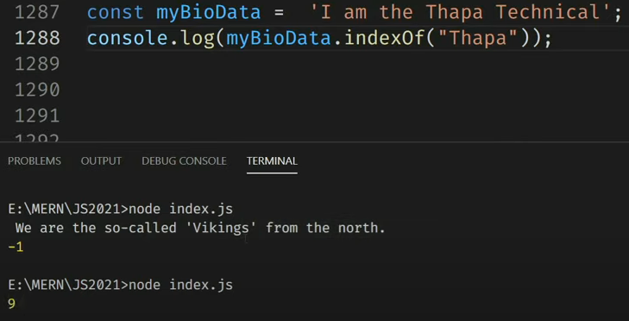

**lastIndexOf():** searches from the backwards.

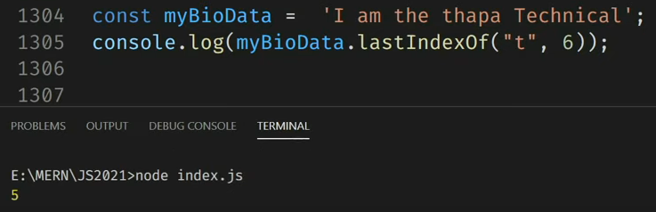

**Search():**

It searches a string for a specified value and returns the position of the match. It cannot take second start position as an argument.

**Extracting a string parts**:

Three methods: slice(start, end), substring(start, end), substr(start, length).

**Slice Method**:

It extracts a part of a string and returns the extracted part in a new string.

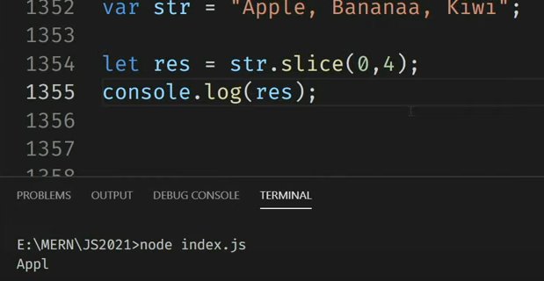

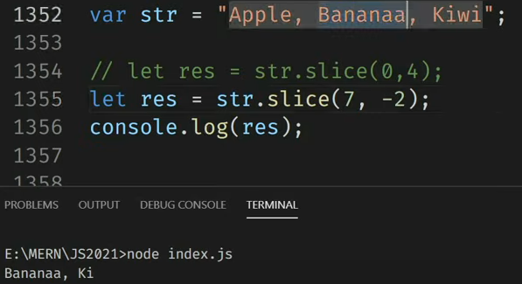

**Substring**():

It cannot accept negative index.

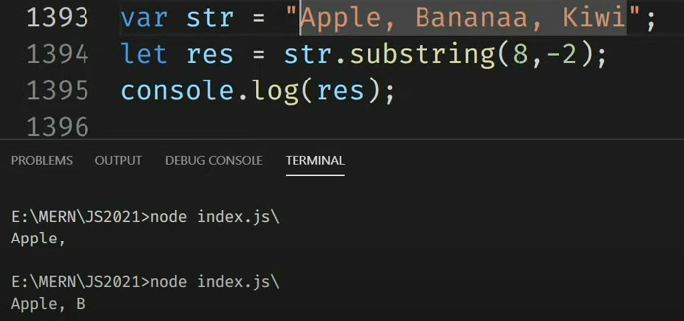

**Substr**():

The second parameter specifies the length of the extracted part.

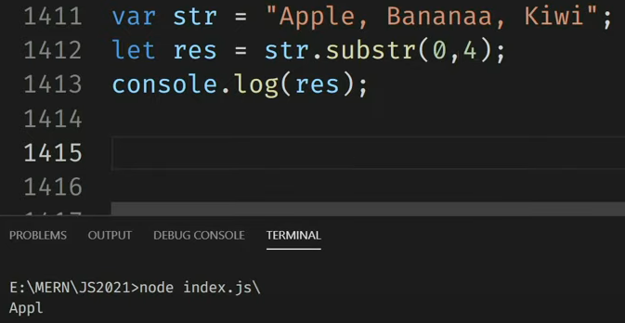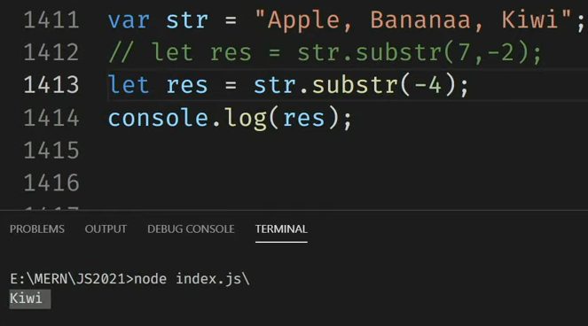

**Replacing string content:**

**Replace():**

It replaces a specified value with another value in a string. It does not change a string but returns a new string. It replaces only the first match. It is case sensitive.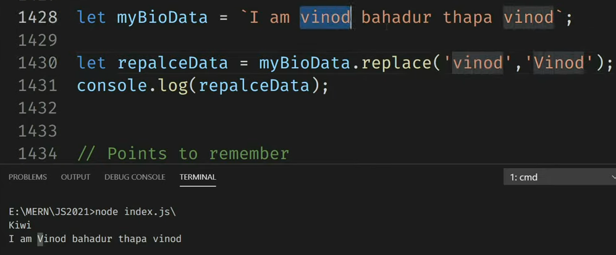

**Extracting string characters:**

3 methods: charAt(position), charCodeAt(positon), Property Access[]

**charAt**():

it returns a character at a specified index in a string.

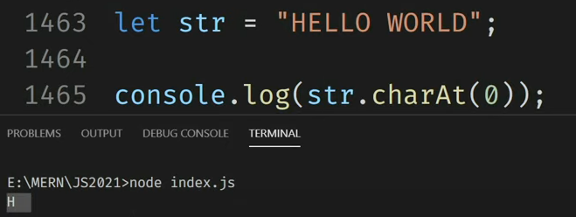

**charCodeAt**():

it returns the Unicode of the character at a specified index in a string. It returns a UTF-16 code, and integer between 65535.

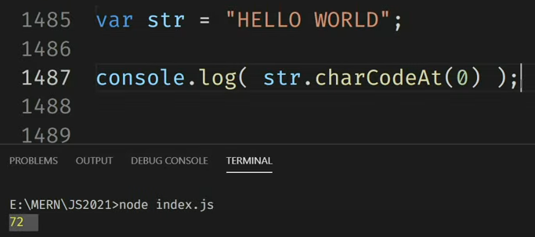

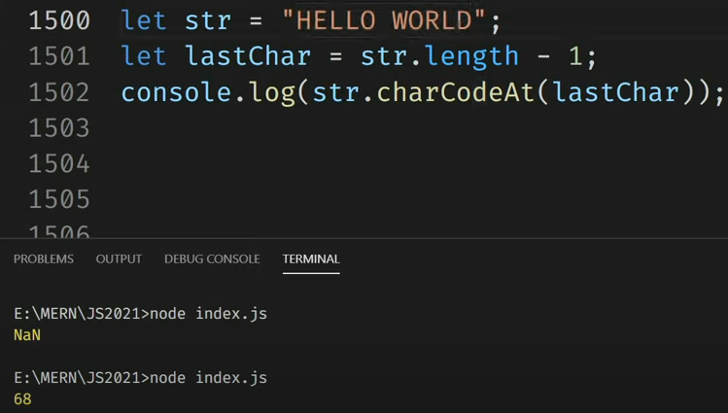

**Property Access:**

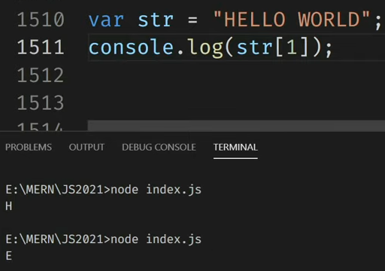

**Uppercase and lowercase method**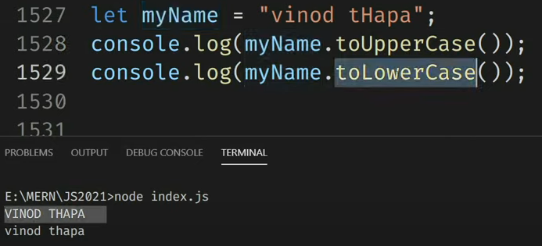

**Concat():**

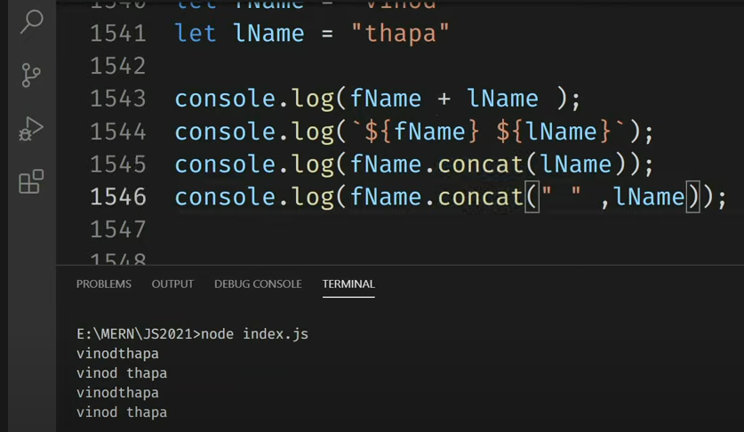

**Trim**(): it removes whitepace from both start and end of a string.

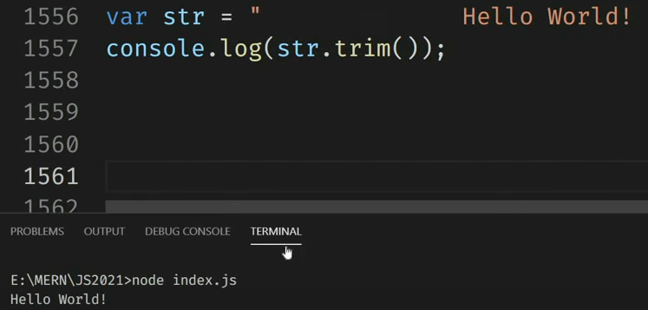

**Split**(): to convert a string into an array.

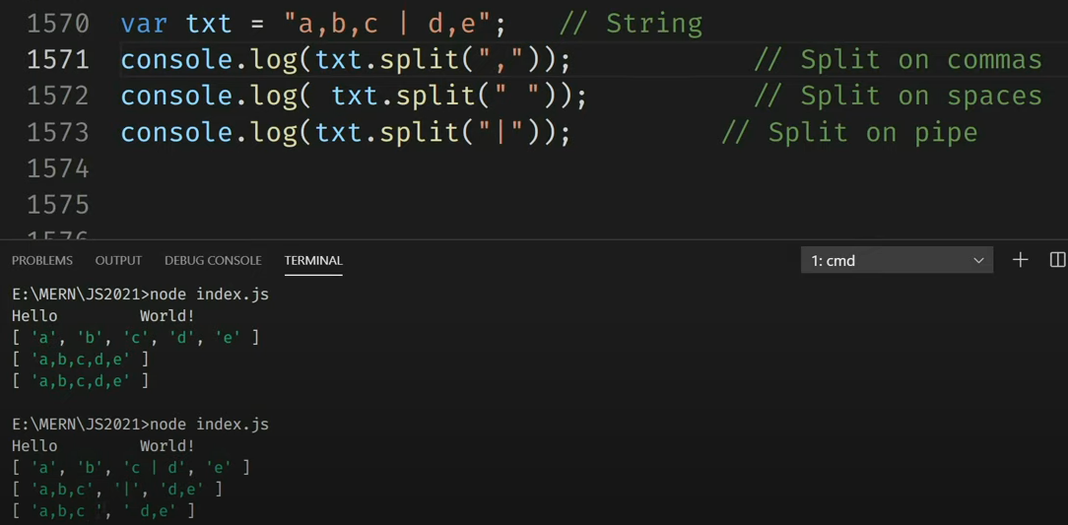

**Date and Time**

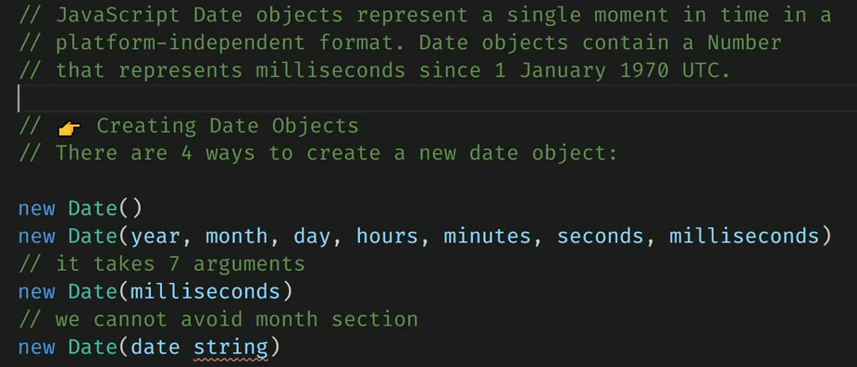

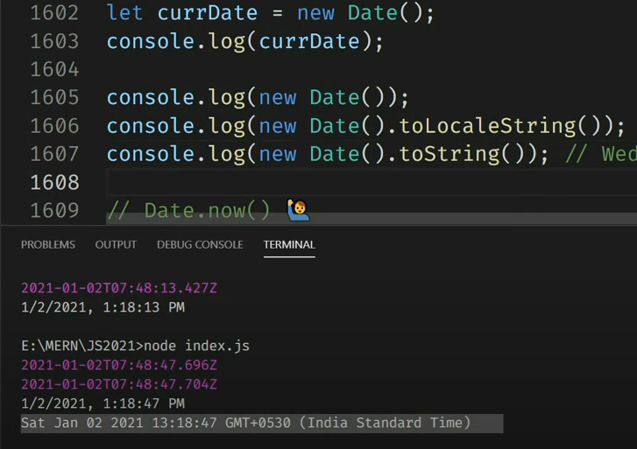

Date.now():

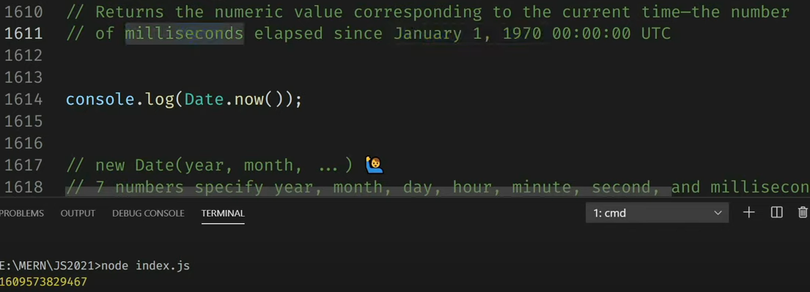

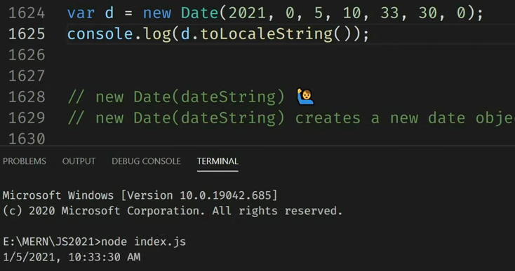

Get date:

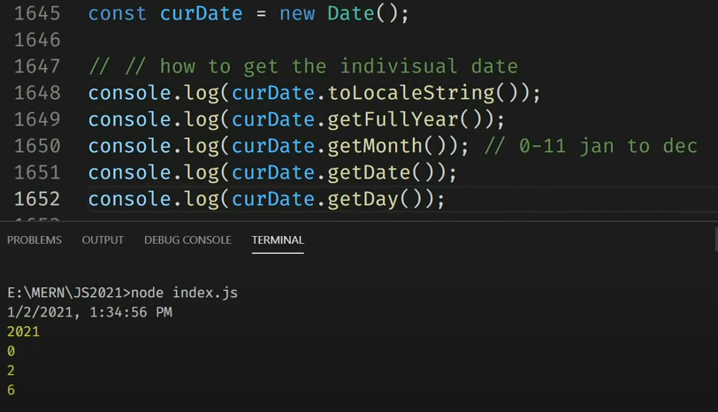

Set date:

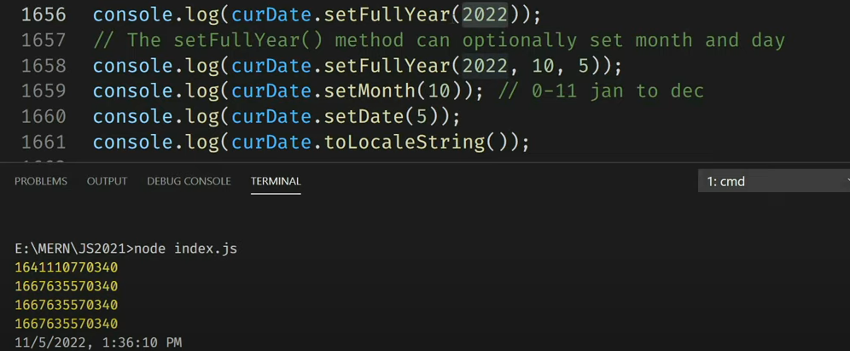

Time:

Get time:

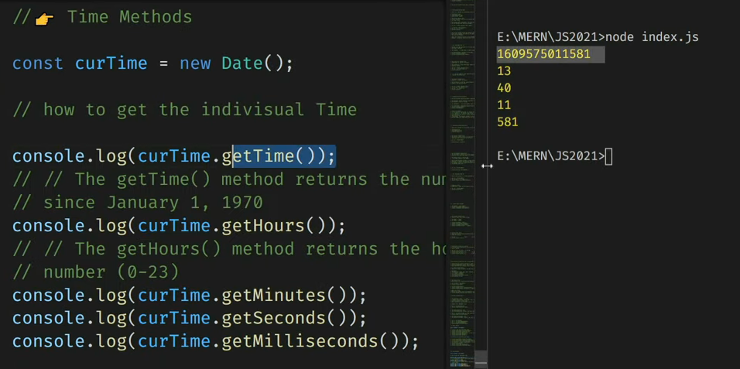

Set time:

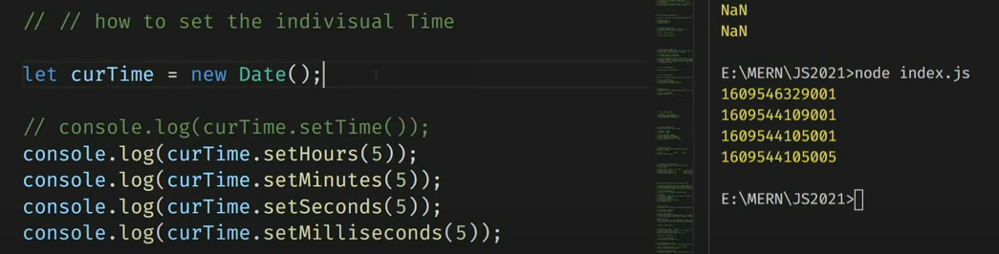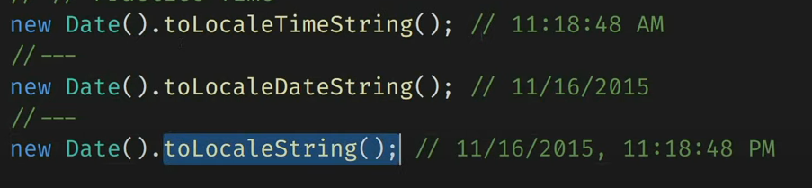

**Math Objects:**

Math.PI()

Math.round()

Math.pow(x,y)

Math.sqrt(x)

Math.abs(x): returns the absolute (positive) value of x

Math.ceil(x)

Math.floor()

Math.min()

Math.max()

Math.random(): returns random number between 0 and 1

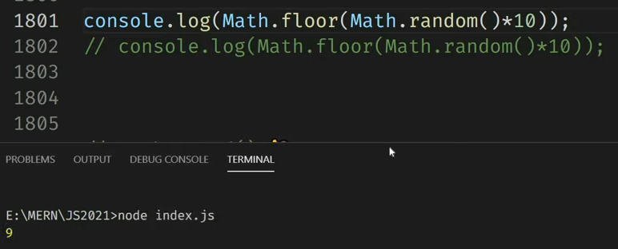

Math..trunc(): it returns the integer part of a number.

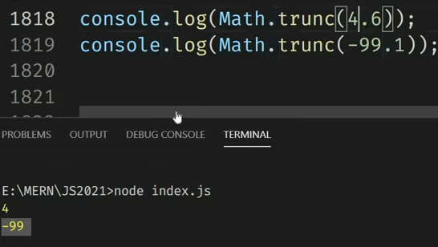

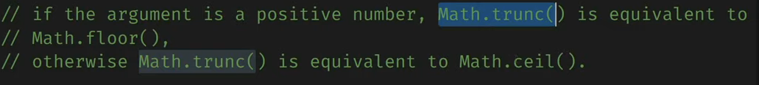

**DOM**

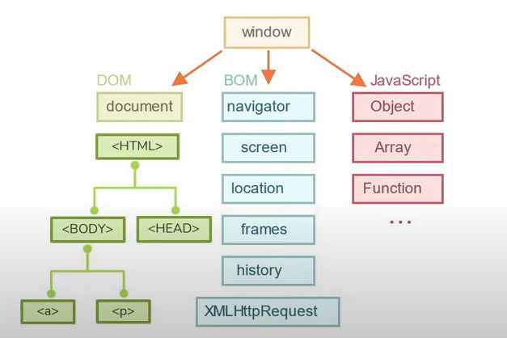

Window.history.back()

Document.body.parentNode

Document.body.childern, document.body.firstchild, document.firstElementChild

Document.body.hasChildNodes() ->. True/false

Document.queryselector(‘.child’)

Document.body.nextSibling

Document.body.previousSibling

Document.body.previousElementSibling

Document.body.nextSibling

Document.body.nextElementSibling

Search and reference:

Search:

Document.getElementById(‘heading’).innerHTML = “welcome”;

Document.getElementsByClassName(‘heading’);

Document.getElementsByTagName(‘p);

Document.getElementsByName(‘gender’);



Document.querySelector(‘#gender’).innerHTML = “welcome”;

Document.querySelectorAll(‘#gender’).innerHTML = “welcome”;

Reference:



**Events**:

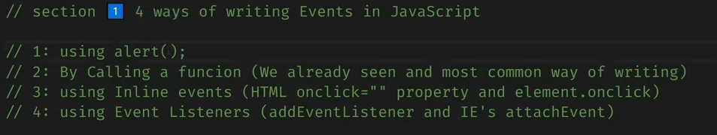

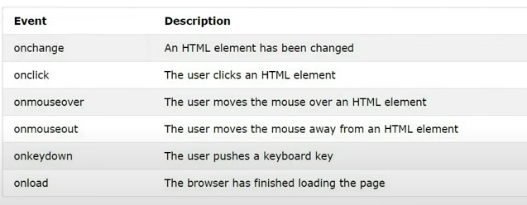

1. Alert():



1. By calling a function:



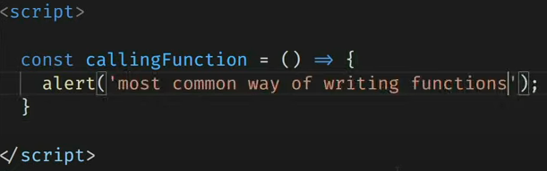

1. By using a reference: in this function is overwritten.

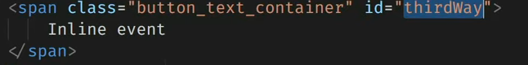

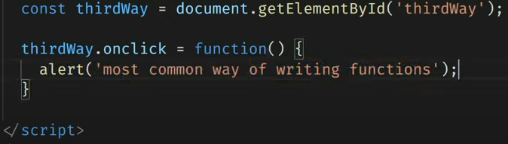

1. Event listener: same event can be called multiple times.

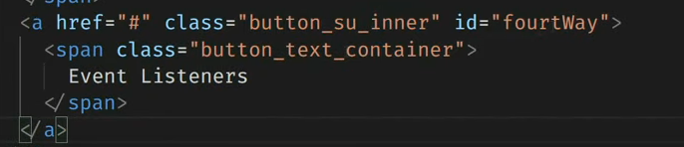

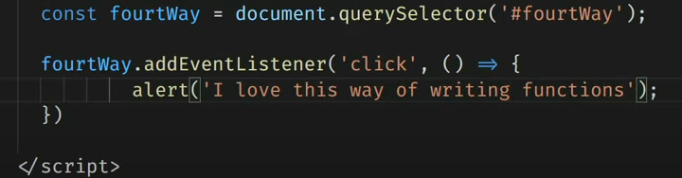

Event Objects:

1. Mouse Event:

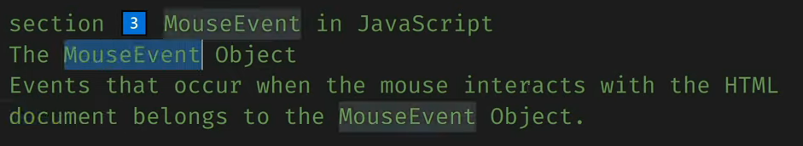

Onmousedown, onmouseup:

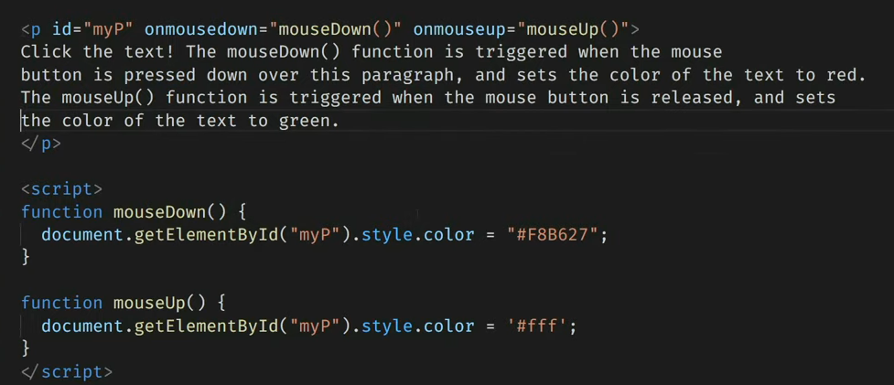

Mouseenter, mouseleave:

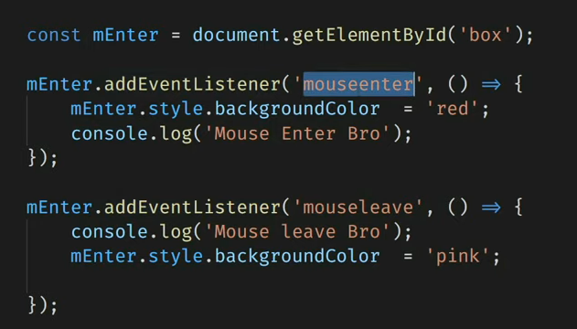

1. Keyboard event:

Onkeypress, onkeydown, onkeyup:

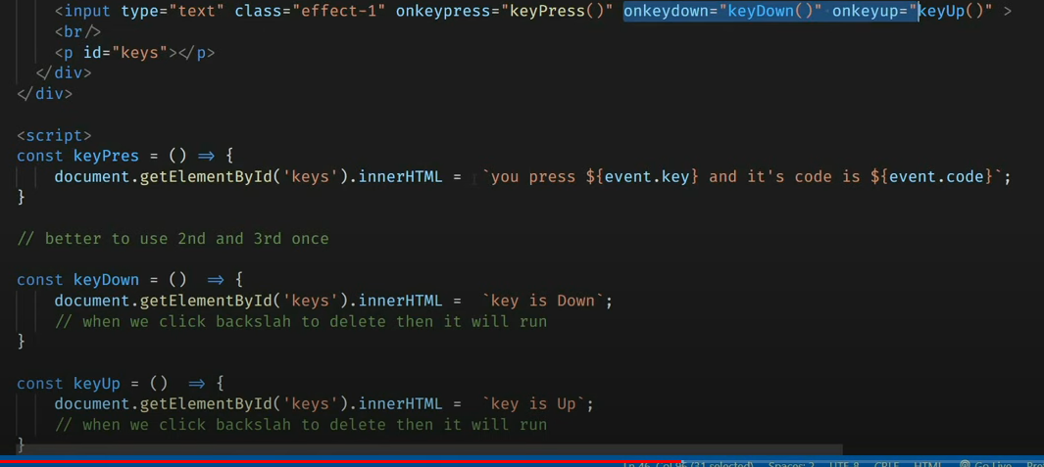

1. **Input events:**

**Onchange**:

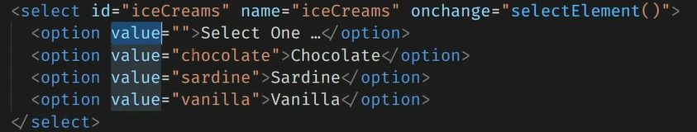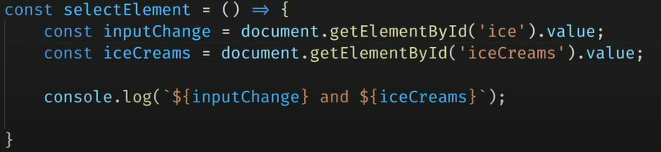

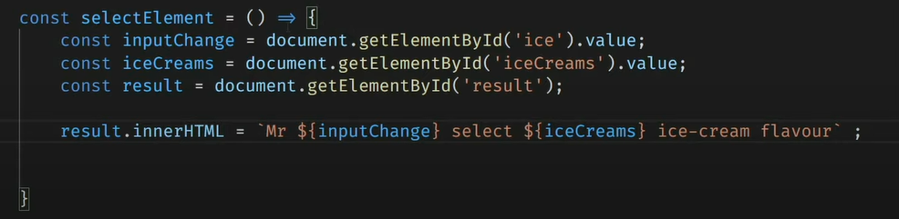

Onchange using reference:

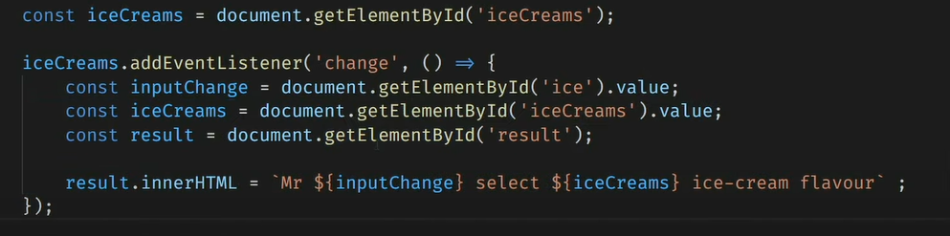

Onclick and addEventListener:

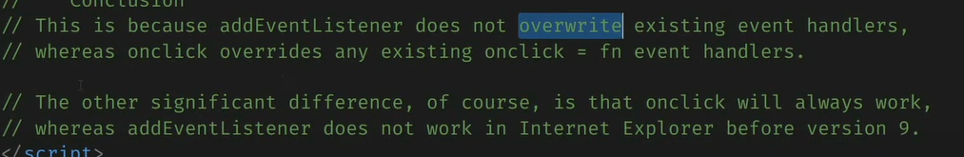

**Timing based events**:

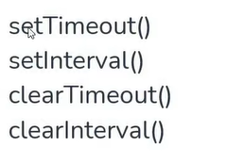

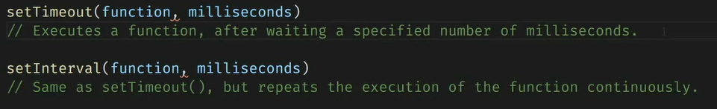

**setTimeout**():

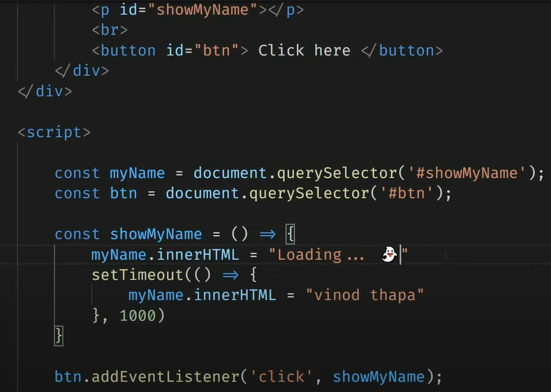

**clearTimeout**(): to stop

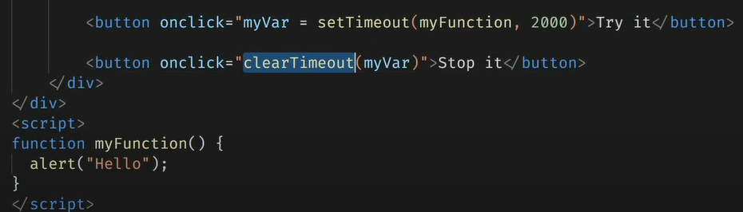

**setInterval**():

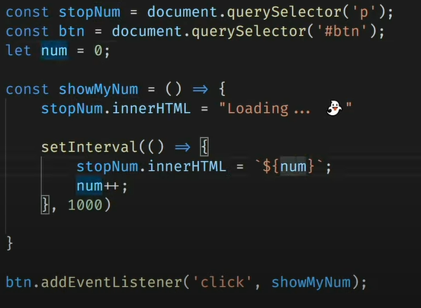

**clearInterval**():

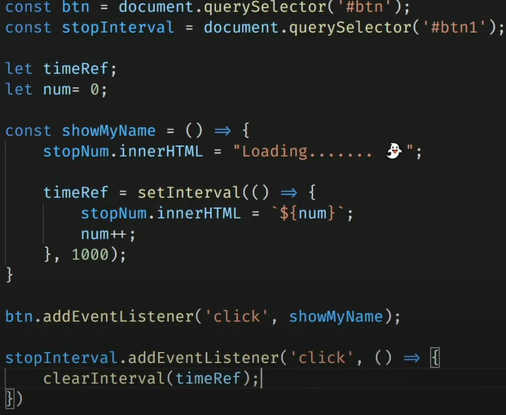

**Object oriented programming in JavaScript:**

Object literals: it is a key: value pair data structure. It stores variables and functions together in one container which is an object.

Create object:

1st way:

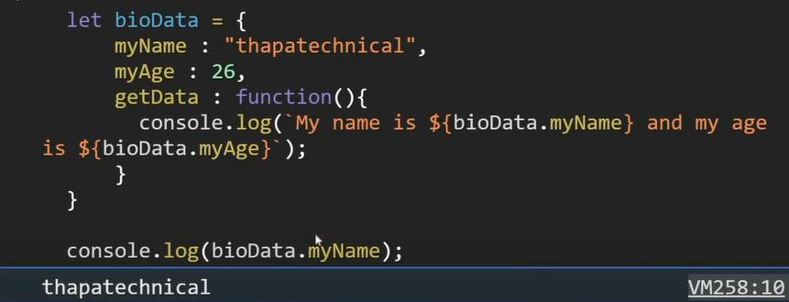

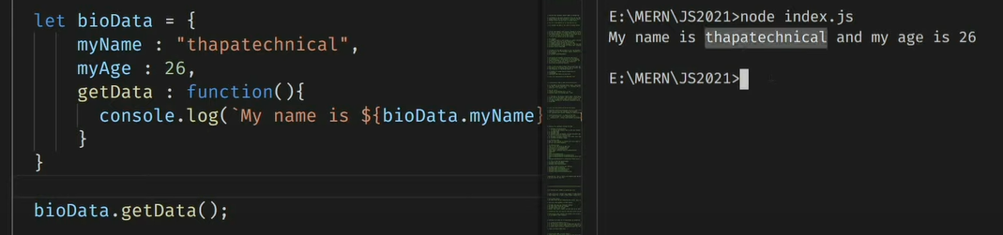

2nd way:

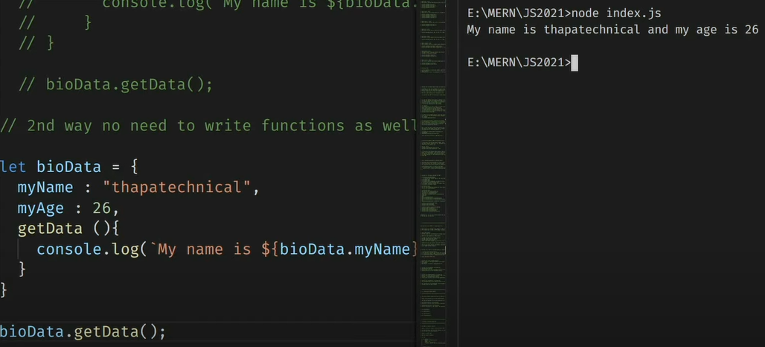

Object as a value inside an object:

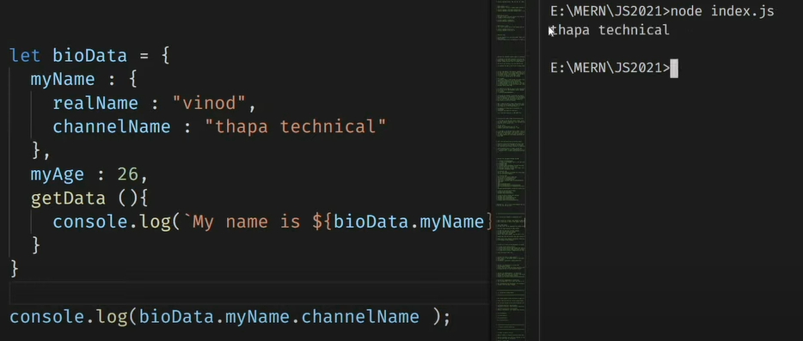

**This Object:**

It contains the current context. This will not work in fat arrow function.

**Array destructuring:**

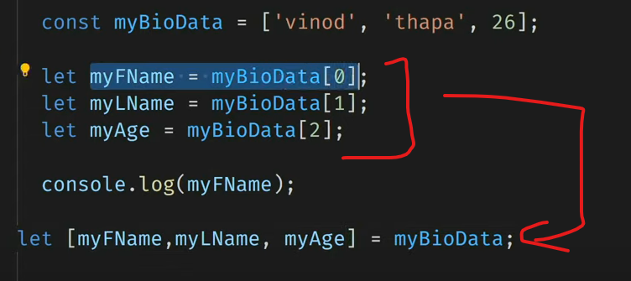

Object destructuring:

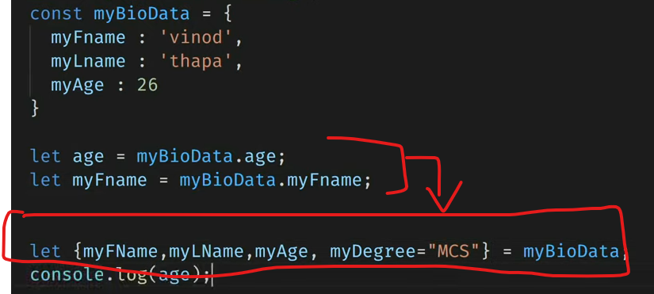

Object properties:

Dynamic properties:

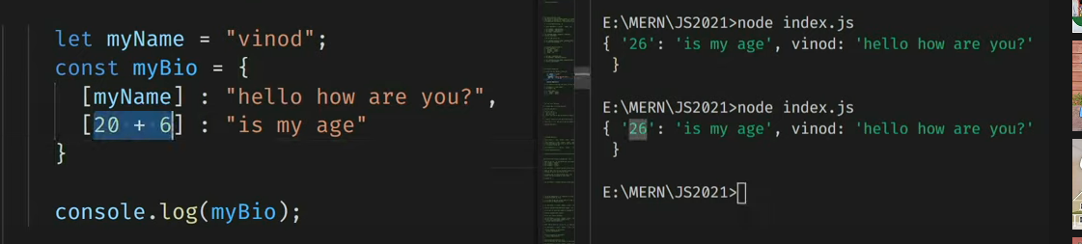

No need to write key and value if both are same.



Spread Operator:

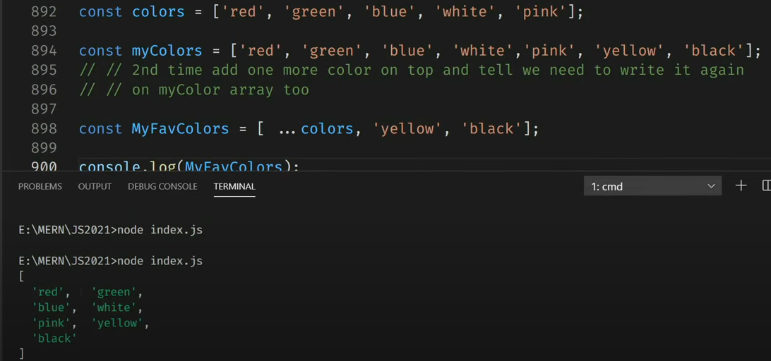

**Es7 features:**

1. **Array include:**

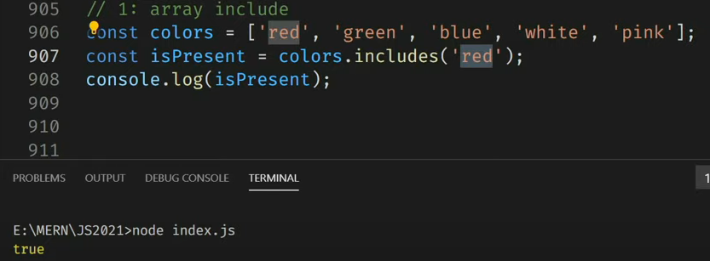

1. Exponential operator:

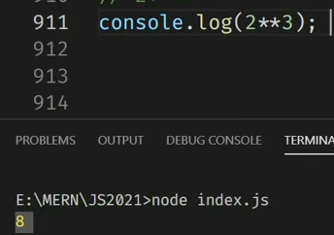

**Es8:**

1. Async await
2. **String padding**: padStart(), padEnd().

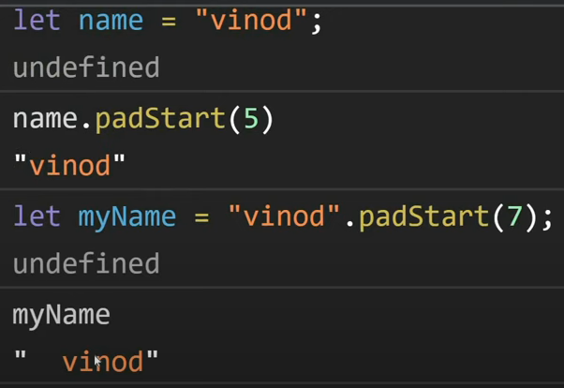

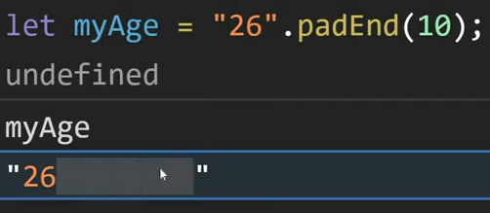

3.object.values():

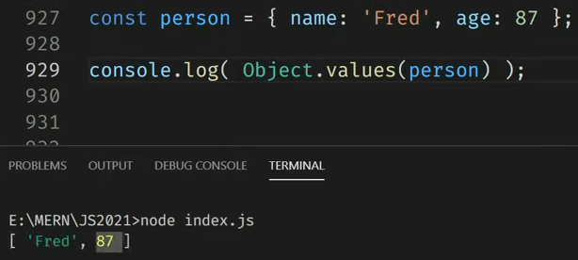

1. **Object.entries():**

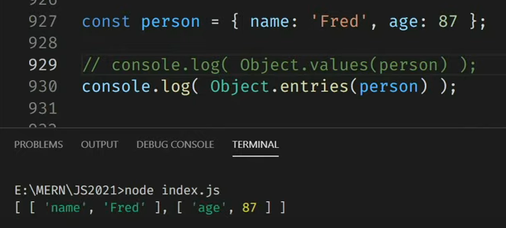

**Es9:**

Object spread operator:

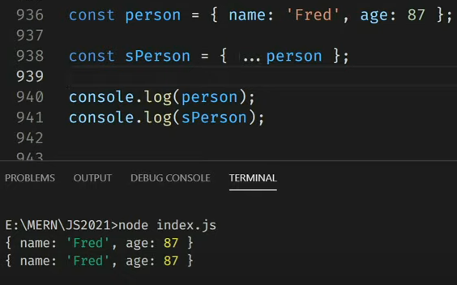

**Es10**:

1. Flat:

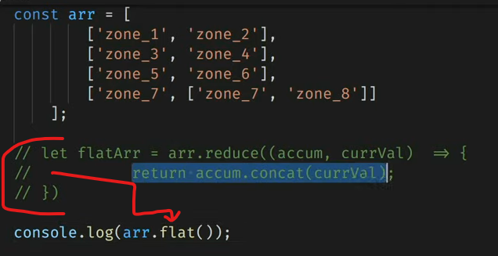

It flats to only 1 level.

Set **Infinity** to have unlimited levels.

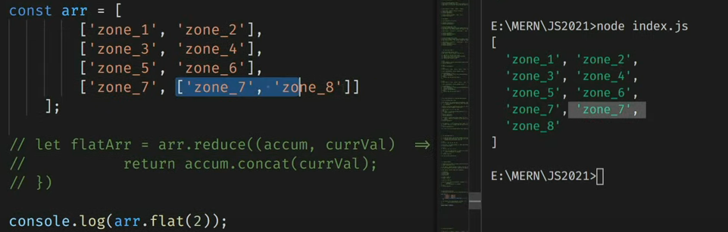

1. Flatmap()
2. formEntries(): convert array to object.

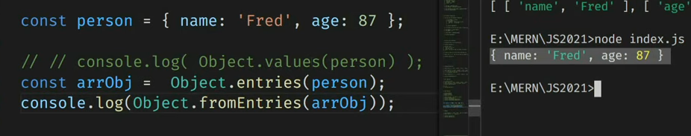

1. trimStart(), trimEnd()

es11:

1.bigint:

Issue in js: To solve this issue, bigint was introduced.

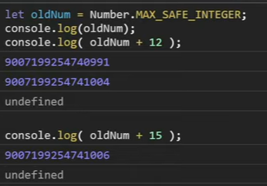

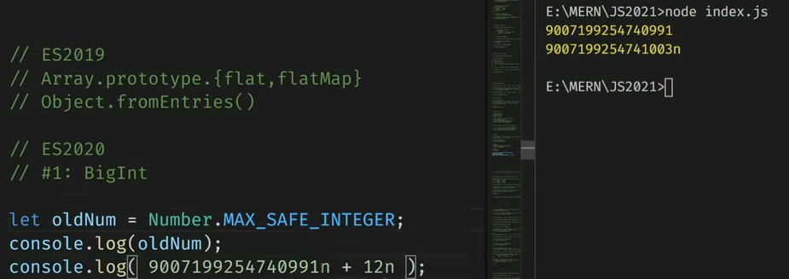

1. nullish coalescing:

**es2014:**

1. use strict: strictly use let, const, var, function etc.

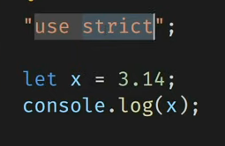

**Advance JS:**event propagation:

Bubbling phase: bottom to top, default

Capturing phase: top to bottom, also known as trickling.

Target phase: propagation start

stopPropagation(): to stop

third argument in addEventListener is for bubble or capturing: true=capturing. Default=false=bubbling

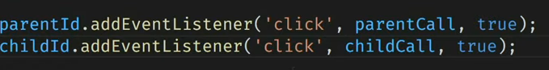

Higher order function

Callback function

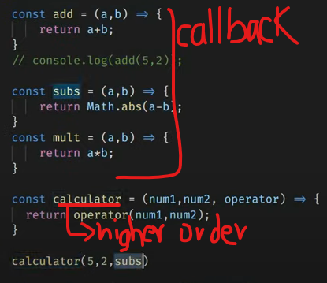

**Asynchronous js:**

**Hoisting**: In this, variables and functions declarations are moved to the top of their scope before the code. This does not work in let and const.

Creation phase and execution phase

Scope chain and lexical scoping:

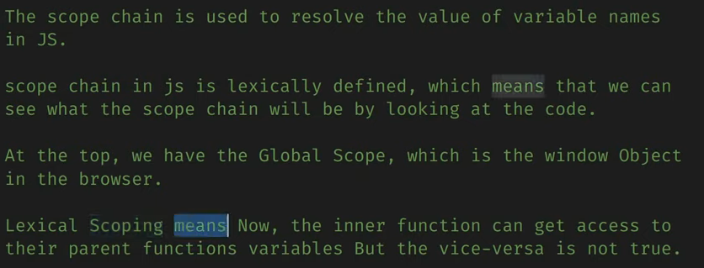

Lexical scoping example:

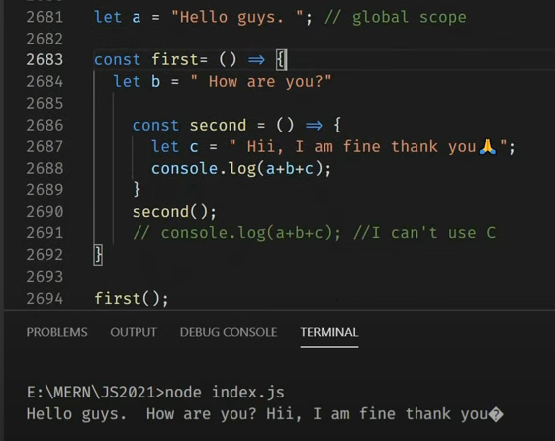

Closures:

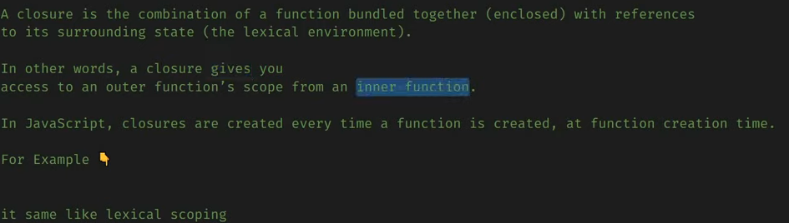

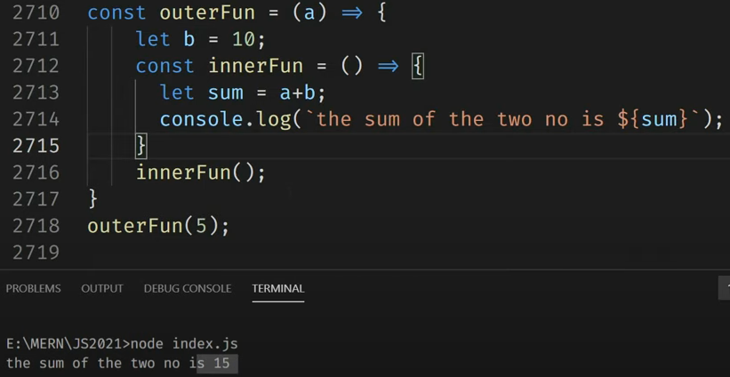

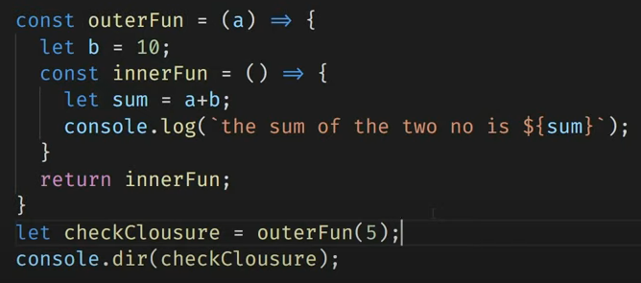

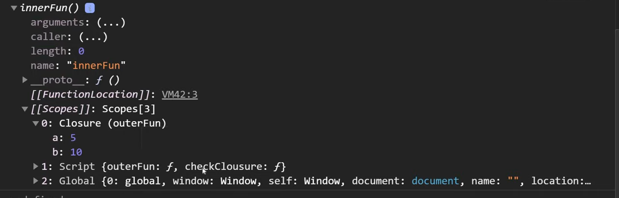

**Synchronous and asynchronous js:**

**Asynchronous js:**

**setTimeout():**

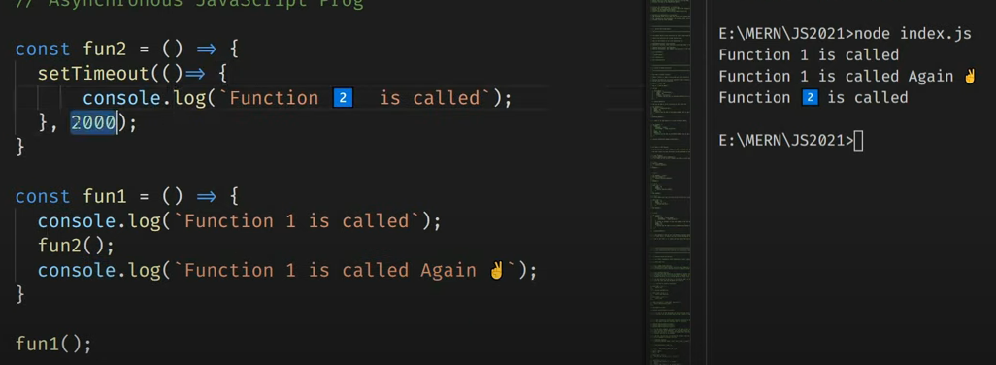

Event loop:

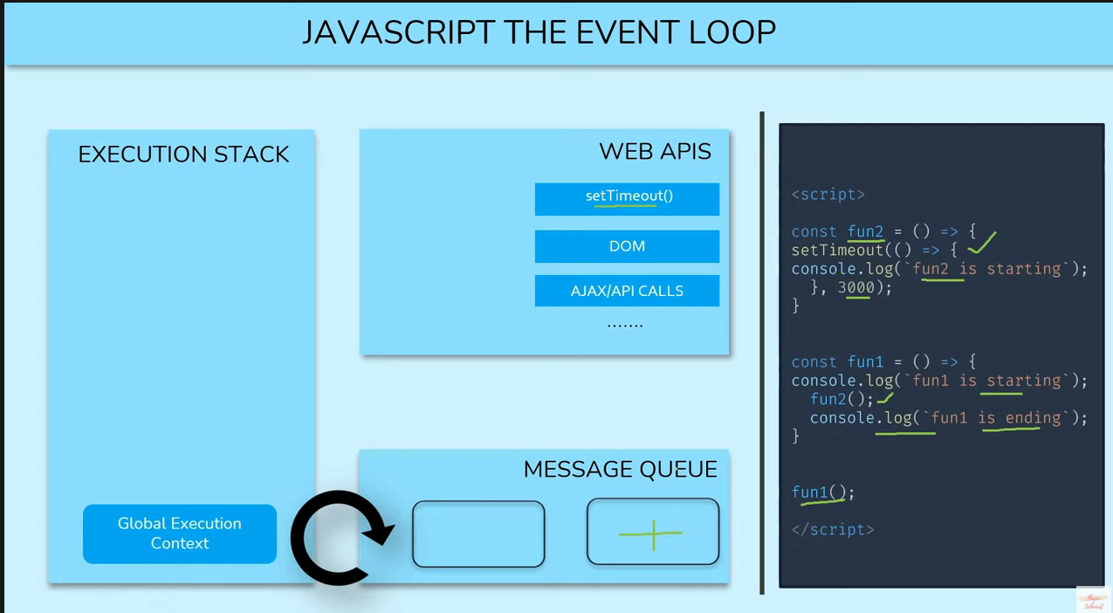

**Function currying:**

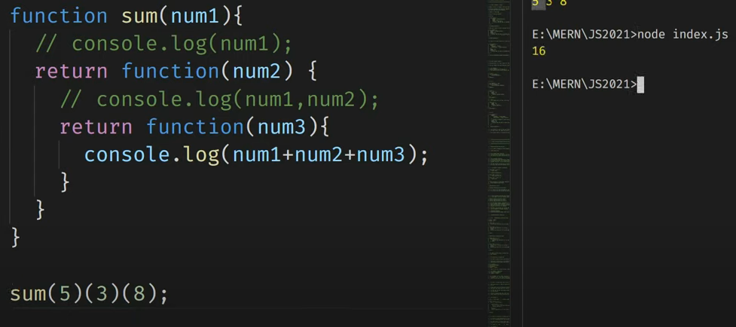

Function currying in one line:

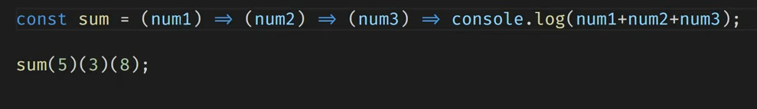

**Call Back Hell:**

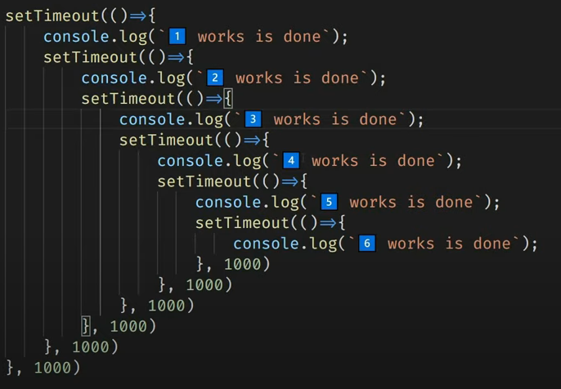

To prevent from call back hell, **Promises** is used.

XML HTTP Request: